REST表達的意思是 REpresentational State Transfer
State意味著數據
REpresentational表示格式（例如 XML、JSON、YAML、HTML 等）
Transfer是指使用 HTTP 協議在消費者和提供者之間傳輸數據

REST API 是一種中間應用程序程式介面，它能夠使兩個應用程序能夠通過 HTTP 相互通信，就像服務器與瀏覽器通信的方式一樣。

JAX-RS 是一種 API 規範，因此我們可以使用 Jersey 或 RestEasy 框架作為 JAX-RS 實現來構建 RESTful Web 服務。

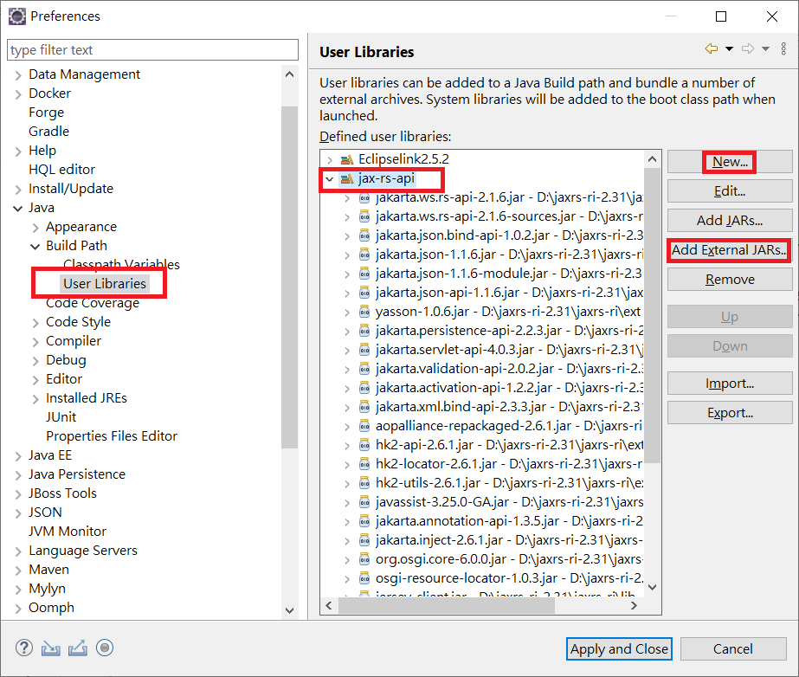
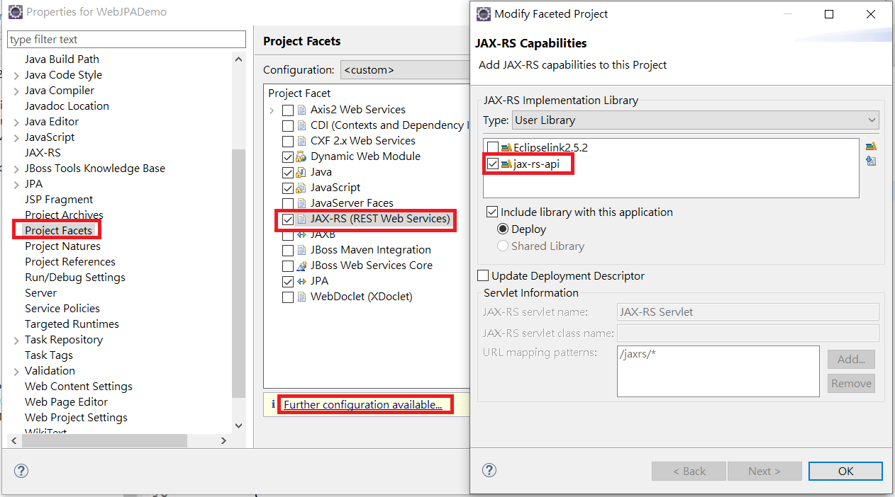
An HTML form by default sends data with content type application/x-www-form-urlencoded.
<form action="api/customers" method="post" >
Name <input type="text" name="name" />
Address <input type="text" name="address" />
Phone Number <input type="text" name="phone-number" />
<input type="submit" value="Submit" />
</form>
JAX-RS 服務方法會攔截 request 並使用 @FormParam 接收資料
@POST
@Consumes(MediaType.APPLICATION_FORM_URLENCODED)
@Produces(MediaType.TEXT_PLAIN)
public String createCustomer(@FormParam("name") String name,
@FormParam("address") String address,
@FormParam("phone-number") String phoneNumber) {
return dataService.addCustomer(name, address, phoneNumber);
}

利用 JAX-RS client API 傳送測試資料給JAX-RS, 而不要用 HTML form.
Form form = new Form();
form.param("name", "Alyssa William")
.param("address", "1021 Hweitt Street")
.param("phone-number", "343-343-3433");

Client client = ClientBuilder.newClient();
WebTarget target = client.target("http://www.example.com/api/customers");
Future<String> response = target.
request(MediaType.APPLICATION_FORM_URLENCODED)
.accept(MediaType.TEXT_PLAIN)
.buildPost(Entity.form(form)).submit(String.class);

使用以下連接提交HTML表單：
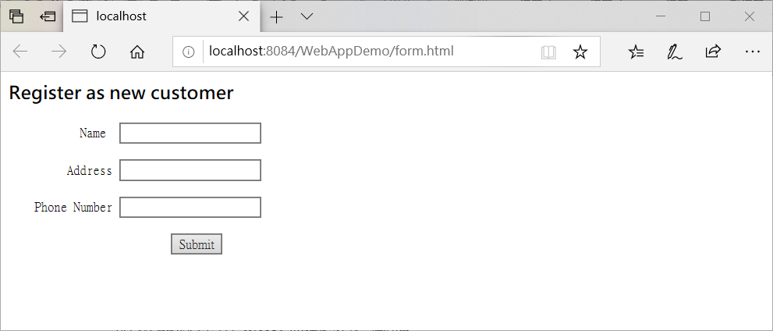
http://localhost:8084/WebAppDemo/form.html
您將看到回應為新建立的客戶ID。您可以使用id訪問新建立的資源：

http://localhost:8084/WebAppDemo/api/customers/1
服務器將使用JSON數據進行回應。

使用表單建立更多客戶資料。
要查看所有客戶使用資源連接：
http://localhost:8084/WebAppDemo/api/customers

MyRestApp.java

import javax.ws.rs.ApplicationPath;
import javax.ws.rs.core.Application;

@ApplicationPath("/api")
public class MyRestApp extends Application {
}

Model 資料結構:
Customer POJO物件類別
package model;
public class Customer {
private String id;
private String name;
private String address;
private String phoneNumber;

public Customer() {
}

public Customer(String id) {
this.id = id;
}

public void setId(String id) {
this.id = id;
}

public void setName(String name) {
this.name = name;
}

public void setAddress(String address) {
this.address = address;
}

public void setPhoneNumber(String phoneNumber) {
this.phoneNumber = phoneNumber;
}

public String getId() {
return id;
}

public String getName() {
return name;
}

public String getPhoneNumber() {
return phoneNumber;
}

public String getAddress() {
return address;
}
}

CustomerDataService.java

package model;

import java.util.ArrayList;
import java.util.List;

public class CustomerDataService {
private List<Customer> customerList = new ArrayList<>();

private static CustomerDataService ourInstance = new CustomerDataService();

public static CustomerDataService getInstance() {
return ourInstance;
}

public String addCustomer(Customer customer) {
String newId = Integer.toString(customerList.size() + 1);
customer.setId(newId);
customerList.add(customer);
return newId;
}

public String addCustomer(String name, String address, String phoneNumber) {
Customer customer = new Customer();
customer.setName(name);
customer.setAddress(address);
customer.setPhoneNumber(phoneNumber);
return addCustomer(customer);
}

public List<Customer> getCustomerList() {
return customerList;
}

public Customer getCustomerById(String id) {
for (Customer customer : customerList) {
if (customer.getId().equals(id)) {
return customer;
}
}

return null;
}
}

JAX-RS 服務
CustomerRestService.java

import model.Customer;
import model.CustomerDataService;

import javax.ws.rs.*;
import javax.ws.rs.core.MediaType;
import javax.ws.rs.core.Response;
import java.util.List;

@Path("customers")
public class CustomerRestService {
private CustomerDataService dataService = CustomerDataService.getInstance();

@GET
@Produces(MediaType.APPLICATION_JSON)
public List<Customer> getCustomers() {
return dataService.getCustomerList();
}

@POST
@Consumes(MediaType.APPLICATION_FORM_URLENCODED)
@Produces(MediaType.TEXT_PLAIN)
public String createCustomer(@FormParam("name") String name,
@FormParam("address") String address,
@FormParam("phone-number") String phoneNumber) {
return dataService.addCustomer(name, address, phoneNumber);
}

@GET
@Path("{id}")
@Produces(MediaType.APPLICATION_JSON)
public Response getCustomer(@PathParam("id") String id) {
Customer customer = dataService.getCustomerById(id);
if (customer == null) {
return Response.status(Response.Status.NOT_FOUND).build();
} else {
return Response.ok().entity(customer).build();
}
}
}

Html Form

<html>
<body>
<h3>Register as new customer</h3>

<form action="api/customers" method="post" >
<pre>
Name <input type="text" name="name" /><br/>
Address <input type="text" name="address" /><br/>
Phone Number <input type="text" name="phone-number" /><br/>
<input type="submit" value="Submit" />
</pre>
</form>

</body>
</html>

import com.logicbig.example.api.CustomerRestService;
import org.glassfish.jersey.server.ResourceConfig;
import org.glassfish.jersey.test.JerseyTest;
import org.junit.Test;

import javax.ws.rs.client.Entity;
import javax.ws.rs.client.WebTarget;
import javax.ws.rs.core.Application;
import javax.ws.rs.core.Form;
import javax.ws.rs.core.MediaType;
import java.util.concurrent.Future;

public class CustomerRestServiceTest extends JerseyTest {

@Override
protected Application configure() {
return new ResourceConfig(CustomerRestService.class);
}

@Test
public void customerRestServiceFormTest() throws Exception {
Form form = new Form();
form.param("name", "Alyssa William")
.param("address", "1021 Hweitt Street")
.param("phone-number", "343-343-3433");

WebTarget target = target("customers");
Future<String> response = target.
request(MediaType.APPLICATION_FORM_URLENCODED)
.accept(MediaType.TEXT_PLAIN)
.buildPost(Entity.form(form)).submit(String.class);
System.out.println(response.get());

String s = target.path("1").request(MediaType.APPLICATION_JSON).get(String.class);
System.out.println(s);
}
}

Get JSON Data:

public class Student {

String firstName;
String lastName;
String school;
String standard;
int rollNumber;

public String getFirstName() {
return firstName;
}
public void setFirstName(String firstName) {
this.firstName = firstName;
}
public String getLastName() {
return lastName;
}
public void setLastName(String lastName) {
this.lastName = lastName;
}
public String getSchool() {
return school;
}
public void setSchool(String school) {
this.school = school;
}
public String getStandard() {
return standard;
}
public void setStandard(String standard) {
this.standard = standard;
}
public int getRollNumber() {
return rollNumber;
}
public void setRollNumber(int rollNumber) {
this.rollNumber = rollNumber;
}

@Override
public String toString(){
return firstName+" "+lastName+" is a student of standard "+ standard+" at "+ school;
}
}

import javax.ws.rs.Consumes;
import javax.ws.rs.GET;
import javax.ws.rs.POST;
import javax.ws.rs.Path;
import javax.ws.rs.Produces;
import javax.ws.rs.core.MediaType;
import javax.ws.rs.core.Response;

@Path("/student/data")
public class RestServer {

@GET
@Path("/get")
@Produces(MediaType.APPLICATION_JSON)
public Student getStudentRecord(){
Student student = new Student();
student.setFirstName("Elizabeth");
student.setLastName("Hayden");
student.setSchool("Little Flower");
student.setStandard("One");
student.setRollNumber(1113);
return student;
}

@POST
@Path("/post")
@Consumes(MediaType.APPLICATION_JSON)
public Response postStudentRecord(Student student){
String result = "Record entered: "+ student;
return Response.status(201).entity(result).build();
}
}

